Evolution
Offspring =the children.
Mate =to have sex.
Fertile =able to mate and produce offspring.
Ancestors =the relatives of a person that lived before them. Your Great Grandad is one of your ancestors.
Generation =the time between the birth of one animal and the time when that animal produces its own offspring.
Species =one type of living thing with shared characteristics. Members of the same species are able to mate with other members of that species and produce fertile offspring.
For example male horses can mate with female horses to produce young horses (offspring). These young horses can grow up to mate and have their own offspring. So horses are in the same species.
A Zebra and a Horse can mate to produce a Zeedonk. A Zeedonk cannot reproduce. A zeedonk is not fertile. A Zebra and hose are not in the same species.

Example | Same species? Yes or no.
A horse and a donkey can mate to give an offspring called a Mule. Mules are not fertile. Mules cannot have baby mules.
Poodle dog and German Shepard dog can mate to give offspring. The offspring are fertile and can grow up to have offspring of their own.
A lion and a tiger can reproduce to give a Liger. A Liger is not fertile. It cannot have babies.

Evolution
Evolution is the change in a species over many generations resulting in new species being made.
For examples the horses we see today evolved from a much smaller animal. This took millions of years to happen.
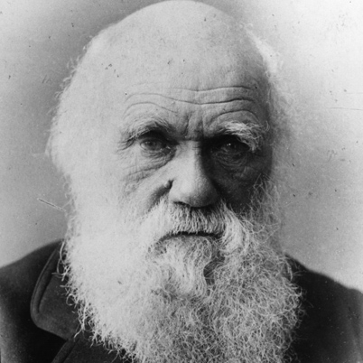
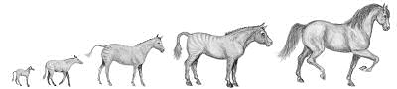

The idea of evolution was thought up by Charles Darwin.

Not everyone agrees with his theory. Here is a cartoon that was drawn of him, at the time his theory was released.
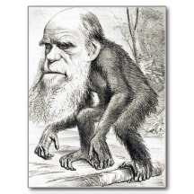
You do not need to believe his theory, but you should understand it.

Evidence for Evolution
- Fossils. By looking at fossils it is possible to see the gradual change in species over time. Fossils are the remains (or an impression) of a plant or animal that existed in a past and has been dug out from the ground.
Here we can see the fossil record of horse skulls.
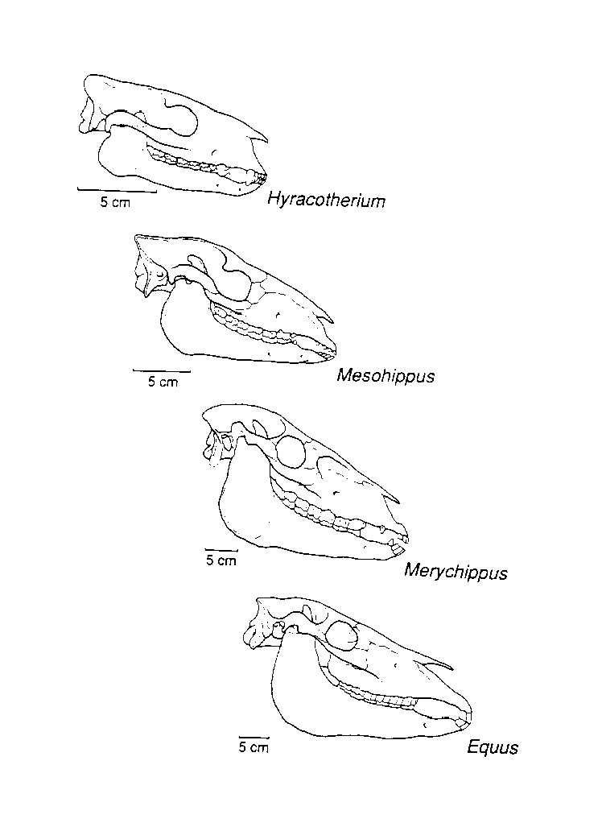
- Homologous structures. This means that some animals share some characteristics parts to their bodies. This suggests that they may have all come from one common ancestor.
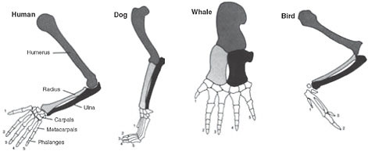
Count how many finger the human hand has. Now count the number of finger like bones in the flipper of the Whale. The idea is that they both come from a common ancestor that had 5 “finger” bones.
Key words
Match the word with the correct definition

Word |  | Meaning(definition)
Mate |  | the children
Species |  | able to mate and produce offspring
Fertile |  | the relatives of a person that lived before them
Generation |  | the time between the birth of one animal and the time when that animal produces its own offspring
Ancestors |  | To have sex
fossil |  | one type of living thing with shared characteristics. Members of the same species are able to mate with other members of that species and produce fertile offspring
Offspring |  | the change in a species over many generations resulting in new species being made
Evolution |  | the remains (or an impression) of a plant or animal that existed in a past geological age and that has been excavated from the soil
Fossils |  | the of a plant or animal that existed in a past has been dug out of the ground

